Le partage oui, mais jusqu’où?

__________________________________________________________________________________________________________________________________________________________________________________________________________________________________________________________________________________________________________________________________________________________________
__________________________________________________________________________________________________________________________________________________________________________________________________________________________________________________________________________________________________________________________________________________________________
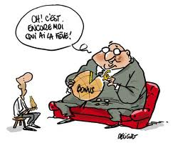
_______________________________________________________________________________________________________________________________________________________________________________________________________________________________________
__________________________________________________________________________________________________________________________________________________________

Quelles questions doit-on poser à nos accompagnés pour les soutenir dans leur cheminement professionnel?

__________________________________________________________________________________________________________________________________________________________________________________________________________________________________________________________________________________________________________________________________________________________________
_________________________________________________________________________________________________________________________________________________________________________________________________________________________________________________________________________________________________________________________
_______________________________________________________________________________________________________________________________________________________________________________________________________________________________________

__________________________________________________________________________________________________________________________________________________________

Quels gestes poser doit-on poser pour instaurer une culture d’insertion professionnelle dans les écoles?

__________________________________________________________________________________________________________________________________________________________________________________________________________________________________________________________________________________________________________________________________________________________________
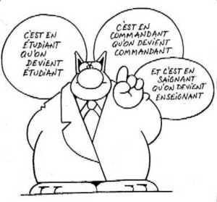
____________________________________________________________________________________________________________________________________________________________________________________________________________________________________________________________________________________________________________________
___________________________________________________________________________________________________________________________________________________________________________________________________________________________
__________________________________________________________________________________________________________________________________________________

Quels sont les effets positifs du programme d’insertion professionnel sur le terrain?

__________________________________________________________________________________________________________________________________________________________________________________________________________________________________________________________________________________________________________________________________________________________________

____________________________________________________________________________________________________________________________________________________________________________________________________________________________________________________________________________________________________________________ _________
___________________________________________________________________________________________________________________________________________________________________________________________________________________________________________________
_________________________________________________________________________________

Si nous avions une rencontre accompagnateur-accompagné, quels sujets pourrions-nous aborder?

__________________________________________________________________________________________________________________________________________________________________________________________________________________________________________________________________________________________________________________________________________________________________
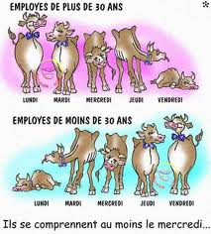
________________________________________________________________________________________________________________________________________________________________________________________________________________________________________________________________________________________________________________________________________________________________________________________
___________________________________________________________________________________________________________________________________________________________________________________________________________________________________________________

Quels sont les avantages de participer aux rencontres entre accompagnateurs?


__________________________________________________________________________________________________________________________________________________________________________________________________________________________________________________________________________________________________________________________________________________________________
_________________________________________________________________________________________________________________________________________________________________________________________________________________________________________________________________________________________________________________________________
_______________________________________________________________________________________________________________________________________________________________________________________________________________________________________________________________
_____________________________________________________________________________________

